- Download caGRID installer from Download Globus from
- Make Sure ANT_HOME and GLOBUS_LOCATION is set
- Copy cagrid-1.2.installer.properties to caGri installer folder
- Create download.properties which containe property download.url=file:/F:/caTissueSuite caGRID Service/caGrid-installer-1.2/cagrid-1.2.installer.properties
- Goto caGrid-installer folder to install caGRID and run command
java -Dhttp.proxyHost=ptproxy.persistent.co.in -Dhttp.proxyPort=8080 -Dhttp.proxyUser=sachin_lale -Dhttp.proxyPassword=<password> -Ddownload.properties="F:/caTissueSuite caGRID Service/caGrid-installer-1.2/download.properties" -jar caGrid-installer-1.2.jar
  - Select target grid
  - On First Screen select caGRID, Others check box unchecked
  - Set “Yes” check box to uncheck for ANT,and Conatiner,and globus installation.
- In castor mapping rename package of AbstractDomain and remove Audit classes
- From caGRID home run command ant introduce
  - On First screen select Create Service Skeleton
  - Select data Service
  - Select caCORE 3.2(1)
  - Select caTissue_Client folder
  - Give path of XMI file generate from Model EAP
  - Error occurs
  - Click OK
  - Select Modify Service
  - Set AbstractDomain class as targetableobjkect false
  - save
- Take patch update if introduce
- Take Introduce patch update of file cagrid-1-0/caGrid/projects/introduce/src/java/Portal/gov/nih/nci/cagrid/introduce/portal/modification/discovery/files/FileTypesSelectionComponent.java from https://gforge.nci.nih.gov/tracker/index.php?func=detail&aid=15614&group_id=25&atid=174

- In SDKQuery32 project modify following:
  - In HQLCoreQueryProcessor.java add applySecurityMethod() and call this method from processQuery as follows

public CQLQueryResults processQuery(CQLQuery cqlQuery)
throws MalformedQueryException, QueryProcessingException {
CQLQueryResults results = null;
checkAuthorization(cqlQuery);
applyUserSecurity();
results = process(cqlQuery);

return results;
}
/**
* This method is added to authenticate caTissue User before calling Appservice
* search
* @throws QueryProcessingException
*/
private void applyUserSecurity() throws QueryProcessingException
{
ClientSession securitySession = ClientSession.getInstance();
String userName = "";
String password = "";
try
{
java.io.InputStream inputStream = new FileInputStream(new File((new StringBuilder()).append(System.getProperty("user.home")).append("/catissueservice/credentials.properties").toString()));
Properties properties = new Properties();
properties.load(inputStream);
userName = properties.getProperty("user.name");
password = properties.getProperty("password");
}
catch(FileNotFoundException e)
{
throw new QueryProcessingException((new StringBuilder()).append("Error logging into caTissue systyem: ").append(e.getMessage()).toString(), e);
}
catch(IOException e)
{
throw new QueryProcessingException((new StringBuilder()).append("Error loading caTissue credentials: ").append(e.getMessage()).toString(), e);
}
try
{
System.out.println("\nLogging using caTissue credentials...");
boolean loggedIn = securitySession.startSession(userName, password);
if(!loggedIn)
throw new QueryProcessingException("CSM security did not log in user");
}
catch(ApplicationException ex)
{
throw new QueryProcessingException((new StringBuilder()).append("Error initializing CSM security: ").append(ex.getMessage()).toString(), ex);
}

  - }
- Goto caGRID_HOME/projects/sdkQuery32 and run : ant all
- Goto caGRID_LOCATION/antfiles/jboss and run command: ant –f jboss.xml deplotJboss –Djboss.dir=”PATH_JBOSS_HOME”
- copy common-logging.jar and log4j.jar from catissue/web-inf/lib to catisue_service/lib and catisue_service/tools/lib
- Goto caTissueSuite_service folder run command: ant deployJBoss -Djboss.dir="F:\caTissueSuite caGRID Service\jboss_caGrid"

Step 1 : Run command ant introduce

Step 2 : Create caGRID service skeleton
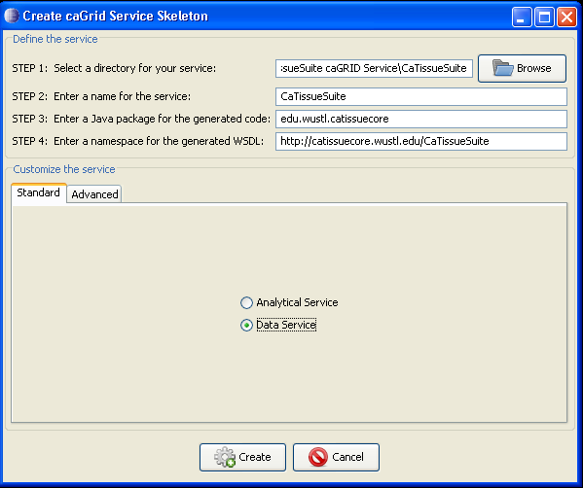

Step 3: Configure data service
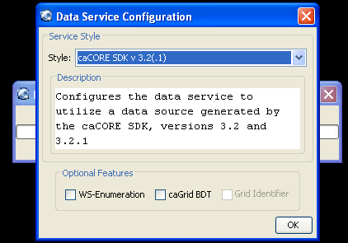

Step 4: Client selection
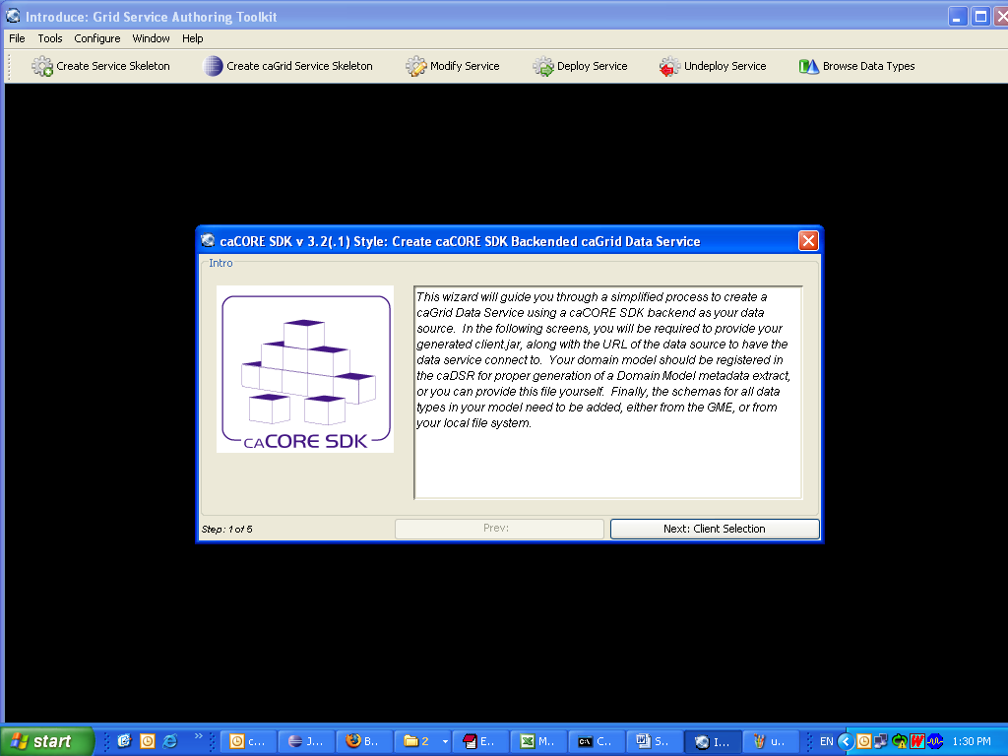

Step 5: Enter folder name contains caTissue caCORE client jars
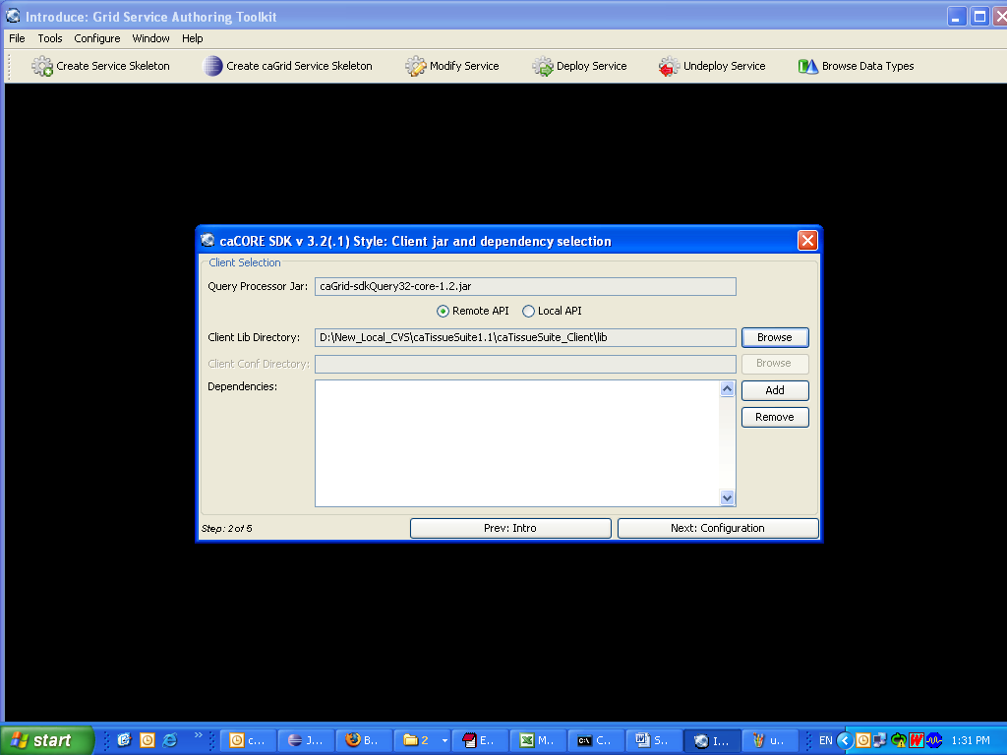

Step 6: Enter App service URL
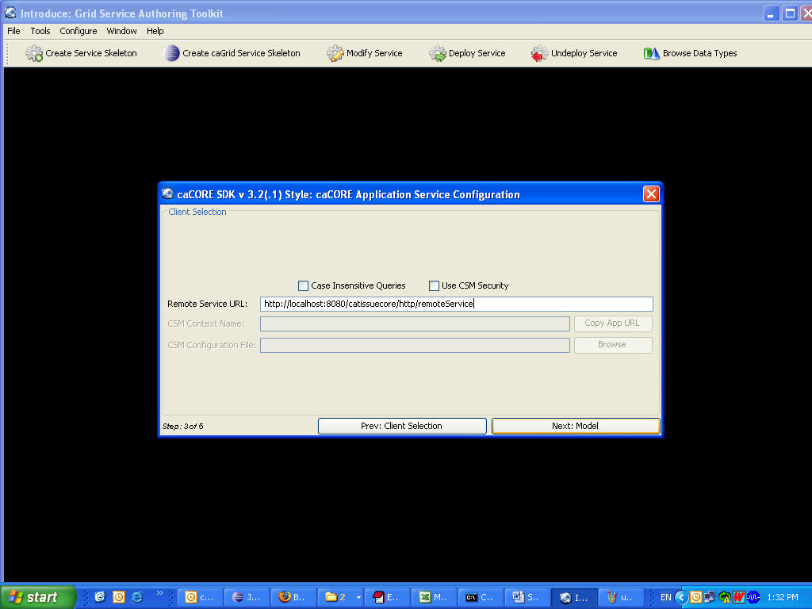

Step 7: Give model XMI file and path to fix-xmi and click OK where D:/New_Local_CVS/CaCORESDK_3_2_1 is a caCORE SDK home dir.
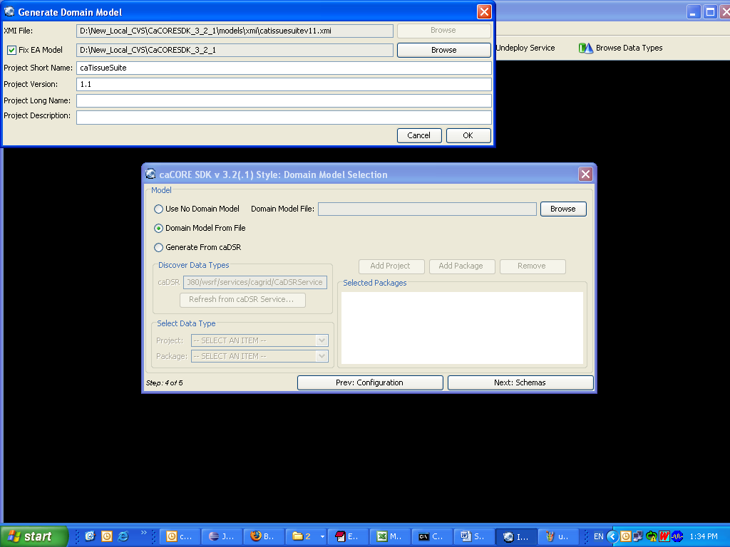

Step 8: Introduce shows following screen
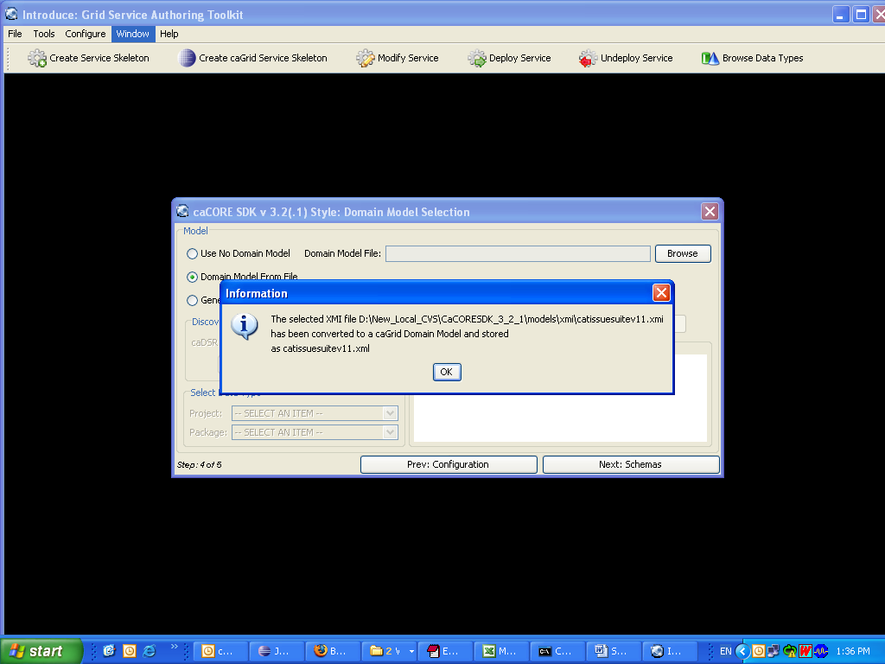

Step 9: Click Next : Schema button on Domain Model selection dialog
Step 10: Following Screen appears

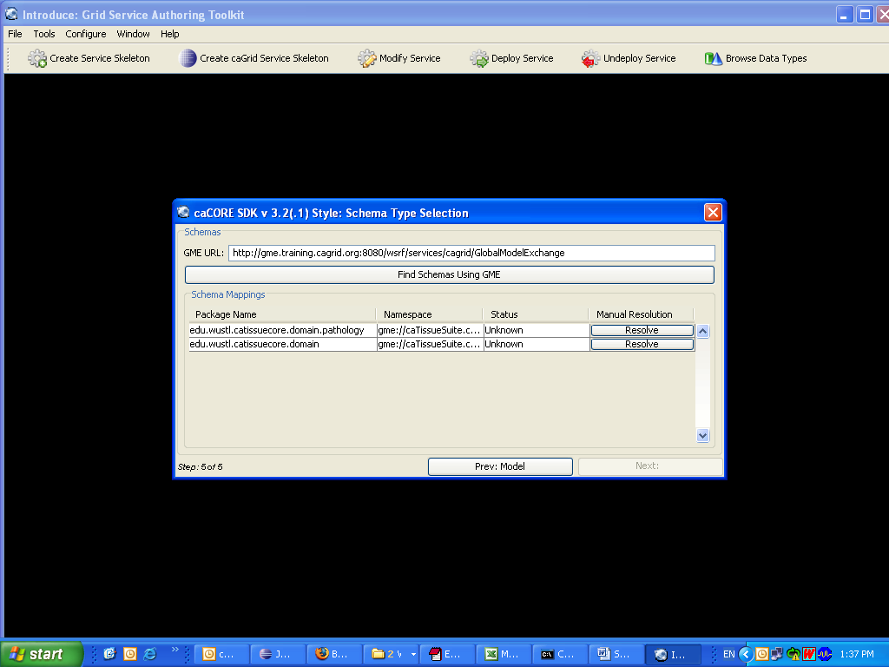

Step 11: Click Resolve button of 2nd row and on screen enter path of edu.wustl.catissuecore.domain.xsd file
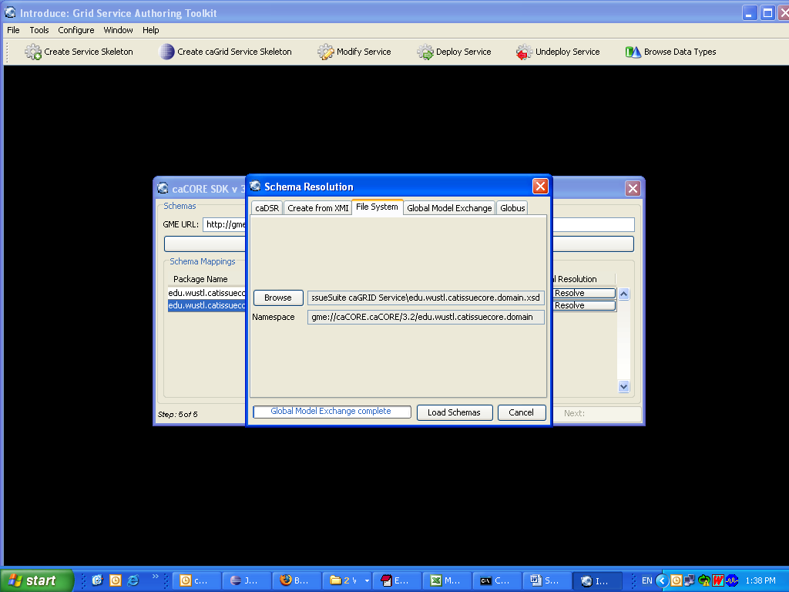

Step 12: Click Load Schemas shows following screen with 2nd row status column as ‘Found’
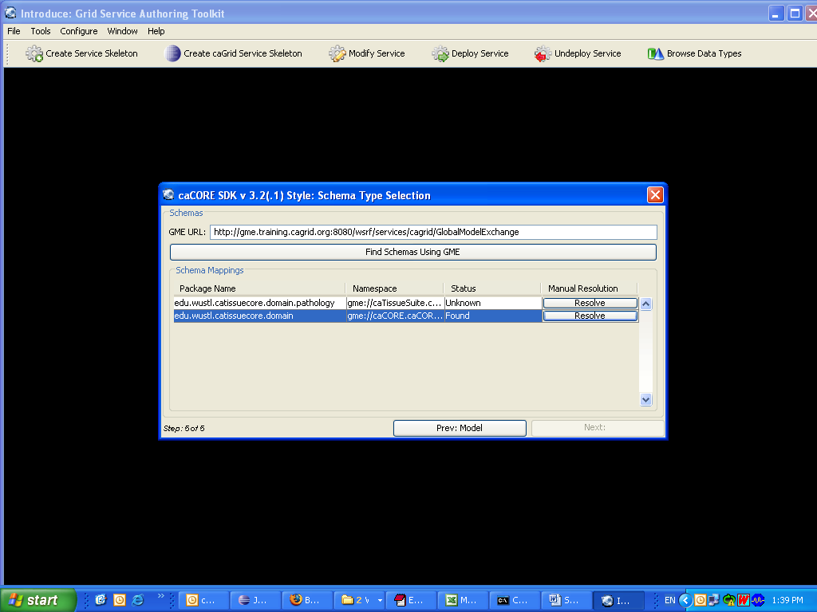

Step 13: Now same for 1st Row click resolve then load schema shows following screen

